Alan D Horn 515733
OCA Photography
Body of Work
Assignment 2

Spend some time reviewing your personal reflection and your tutor feedback. Develop a series of carefully considered images that moves your idea forward. Hand in this series to your tutor together with a new reflective commentary setting out where you plan to go from here.

Continuing my study of the dramatic erosion in Happisburgh, I am likely to conclude that despite the cliffs being an area of Special Scientific Interest (SSSI), they will not be protected (as this suits Natural England and the British Museum) and a large part of the village will gradually collapse into the North Sea.

I am continually visiting as the erosion is dramatic and it will continue to create good documentary photo opportunities. Latest data from Confused.com states " Happisburgh is the most at-risk area of coastal erosion in the UK over the next 20 years" and suggests that Happisburgh Cliffs will collapse by approximately 100m within 20 years and 150m within 50 years although if there are more of the severe storms experienced in recent years, further acceleration of erosion is inevitable.

I will also start to include images of properties that are doomed and the personal stories of people who own them. I have made a number of good local contacts including Denise Burke, a local councillor and Bryony Nierop-Reading, who owns one of the 15-20 houses within a 100m range of the cliff edge. She has allowed me to use an upstairs room to take images of the two bungalows that will be demolished within the next 12 months and has guided me through the garden of one of the latest condemned properties so I can "safely" peer over the edge.
My next visit will include the use of a drone to illustrate the precarious nature of the cliff top properties. I will also study the "sandscaping" and "beachscaping" initiatives in Bacton and Weybourne.

The images I am including cover some of the properties lying within 100mtrs from the cliff edges and
the most recent increases in land-sliding.

Properties within the 100m range of the cliff edge.

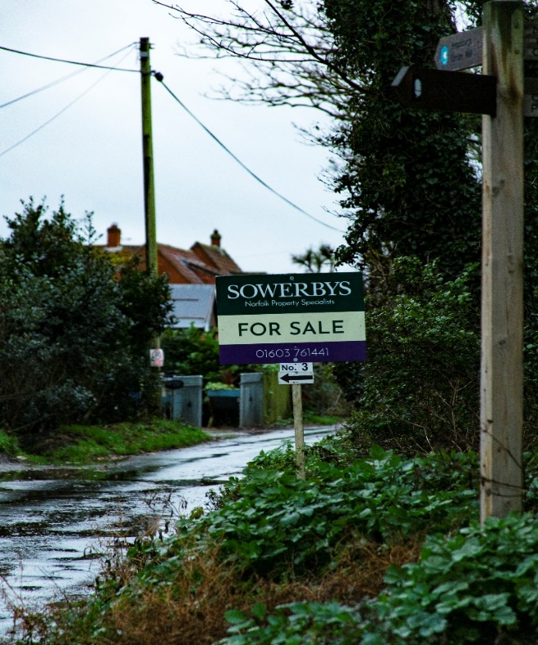 Fig 1 Beach Road

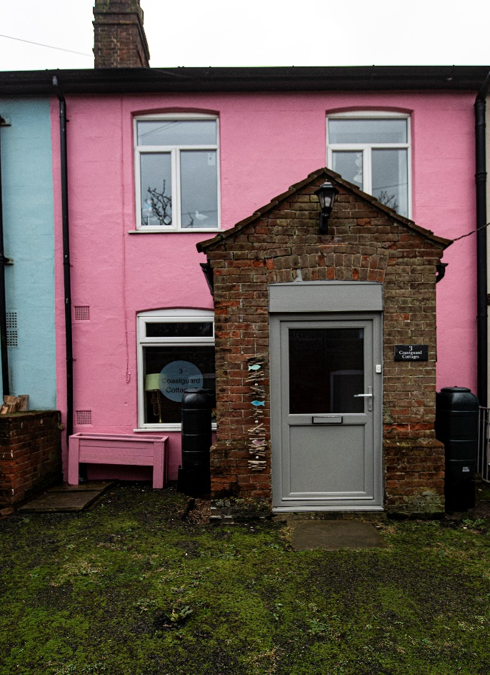 Fig 2 No.3 Coastguard Cottages

No.3 Coastguard Cottages is a holiday let now up for sale at £190,000. A mortgage is not available so a cash buyer is the only option. It is hard to see the logic of buying a property that will fall into the sea within 20 years maximum. Even as a holiday let it would need to generate circa £13K pa to just break-even with no residual value.

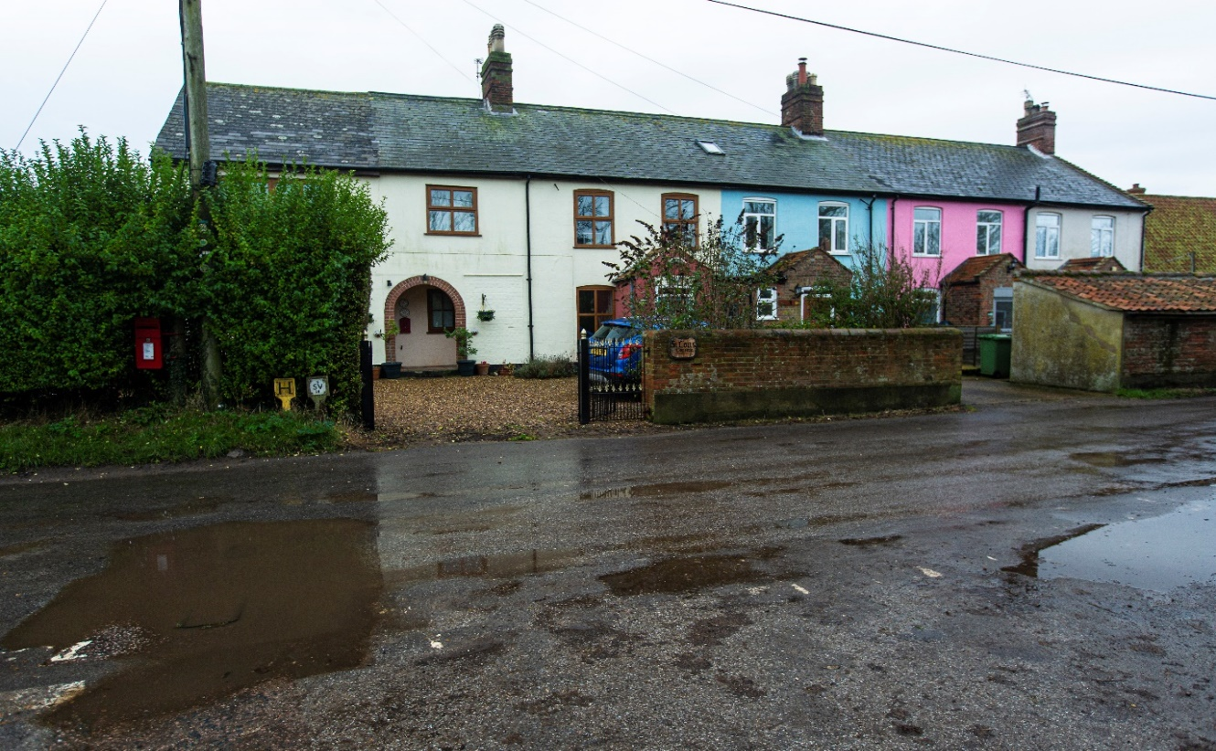
Fig 3 Coastguard Cottages

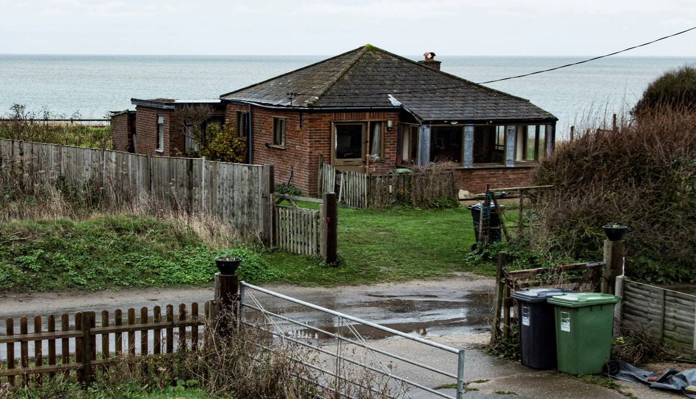
Fig 4 Beach Road Bungalow

The garden of this the Beach Road bungalow is already falling into the sea and the property will have to be demolished in 2020. This will be closely followed by Blake Cottage, just 30m along the road which is owned by the same family!

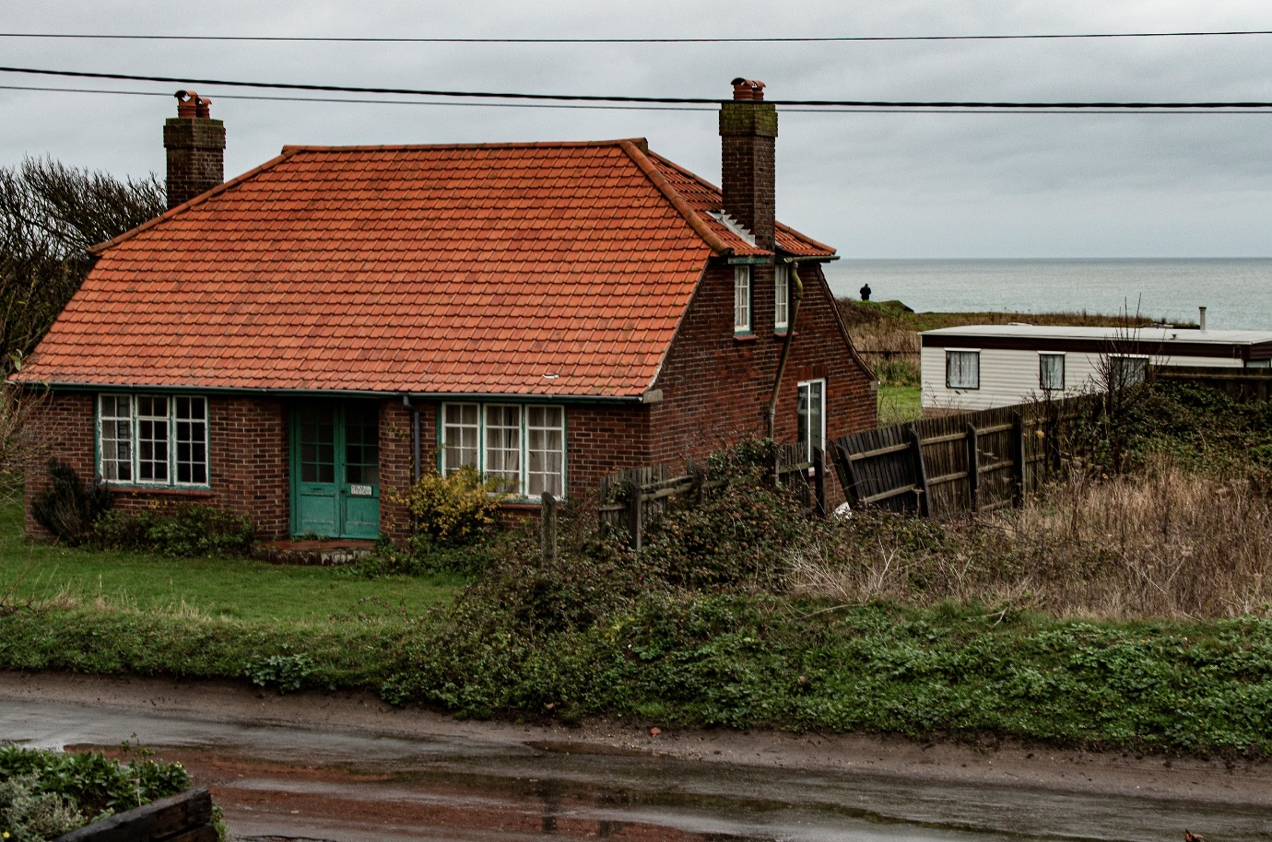
Fig 5 Blake Cottage

There is no compensation available to householders who lose their properties.

Erosion

Recent heavy rainfall has caused more slippage and evidence that the "Rock Armour" has limited effect from high tides.

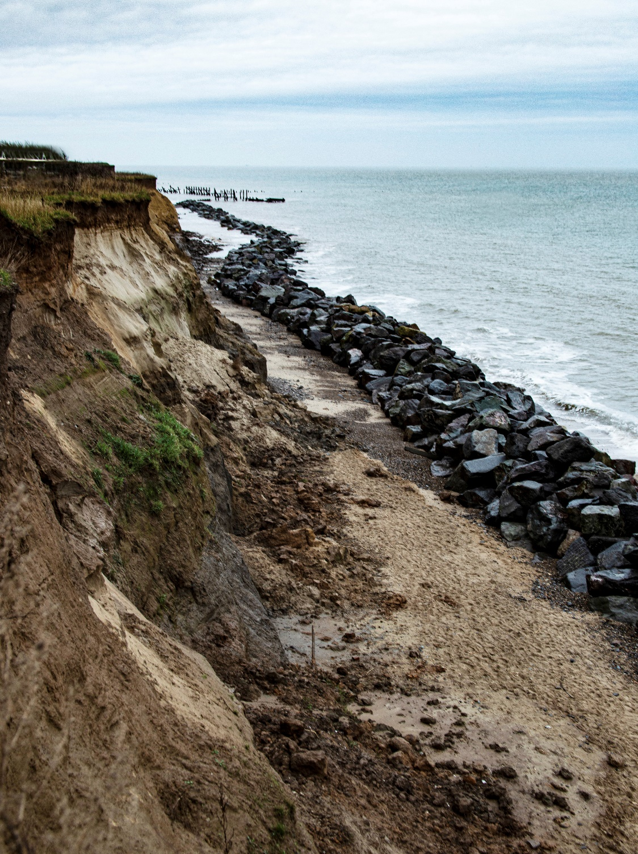
Fig 6

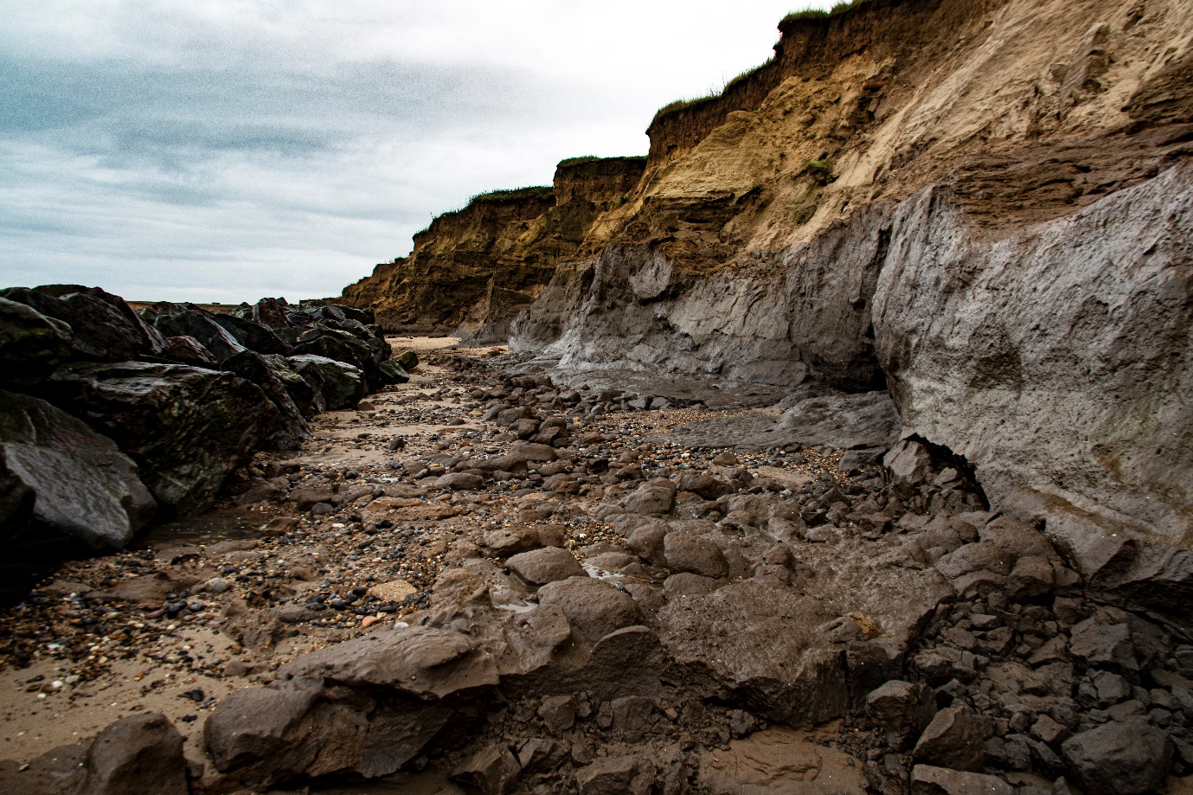
Fig 7

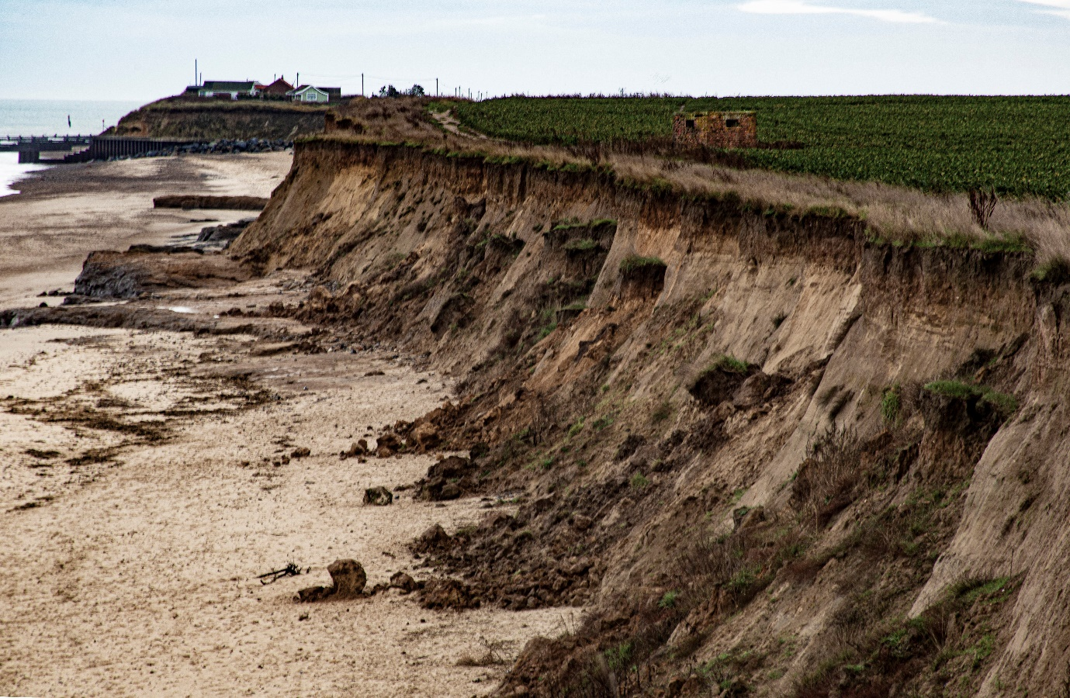
Fig 8 Pill box was 200m from the sea 20 years ago

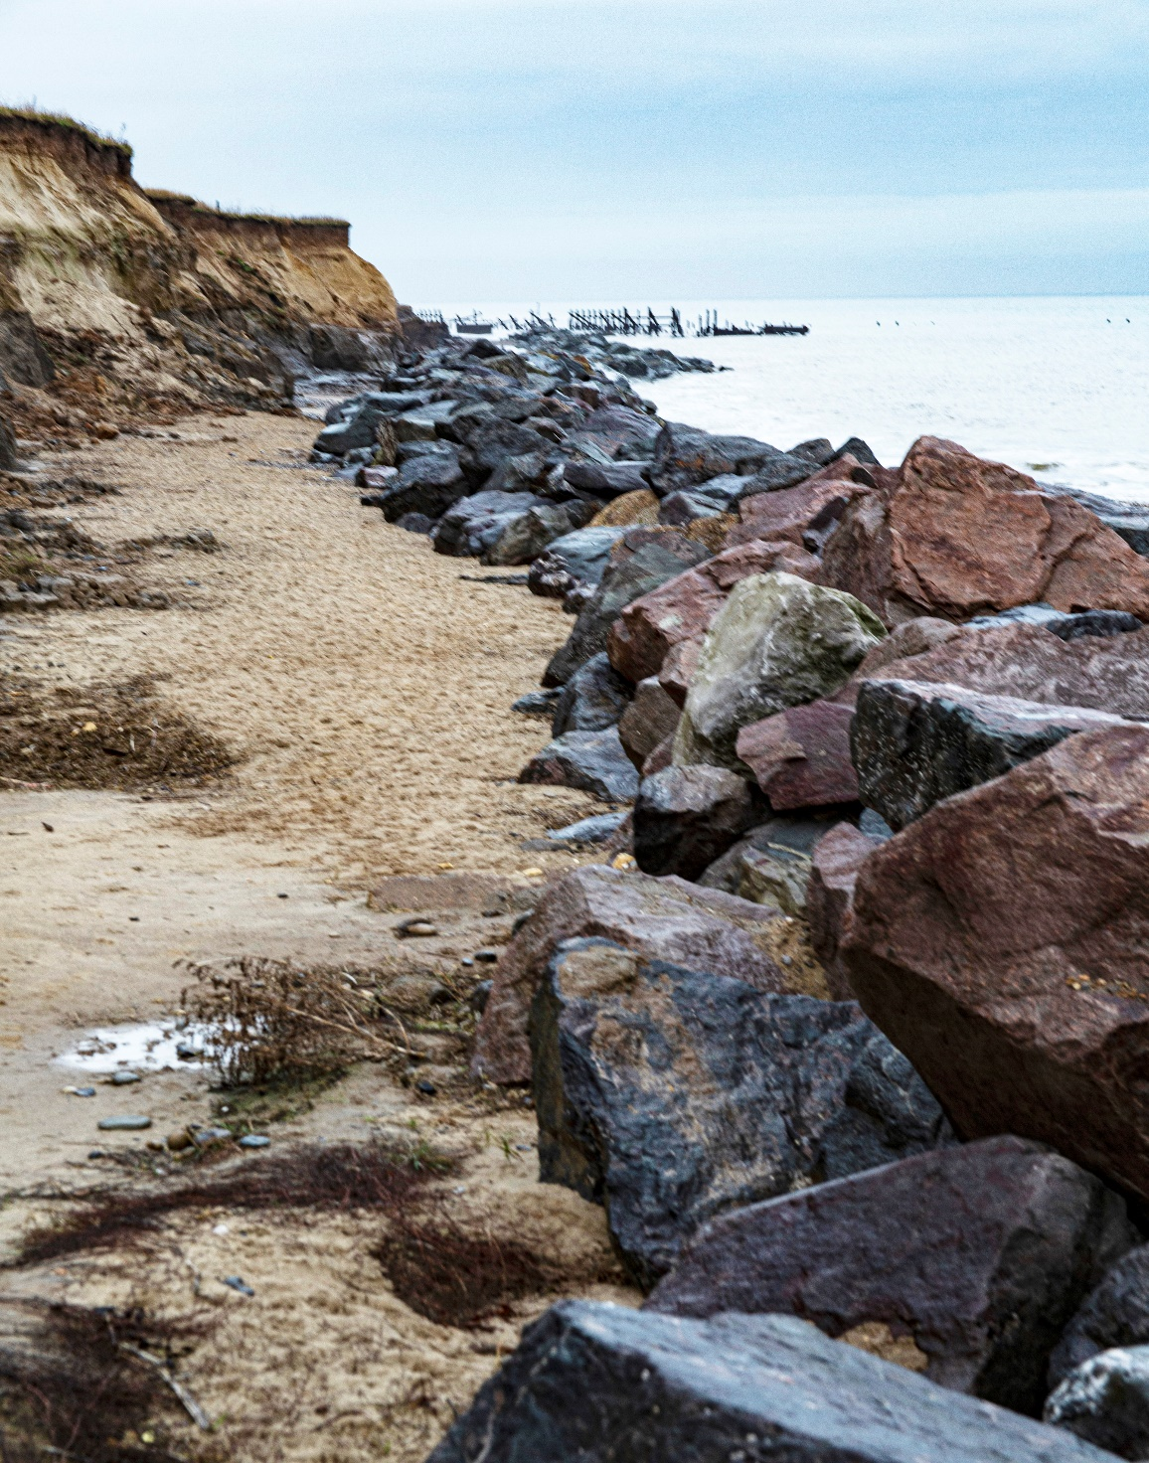
Fig 9

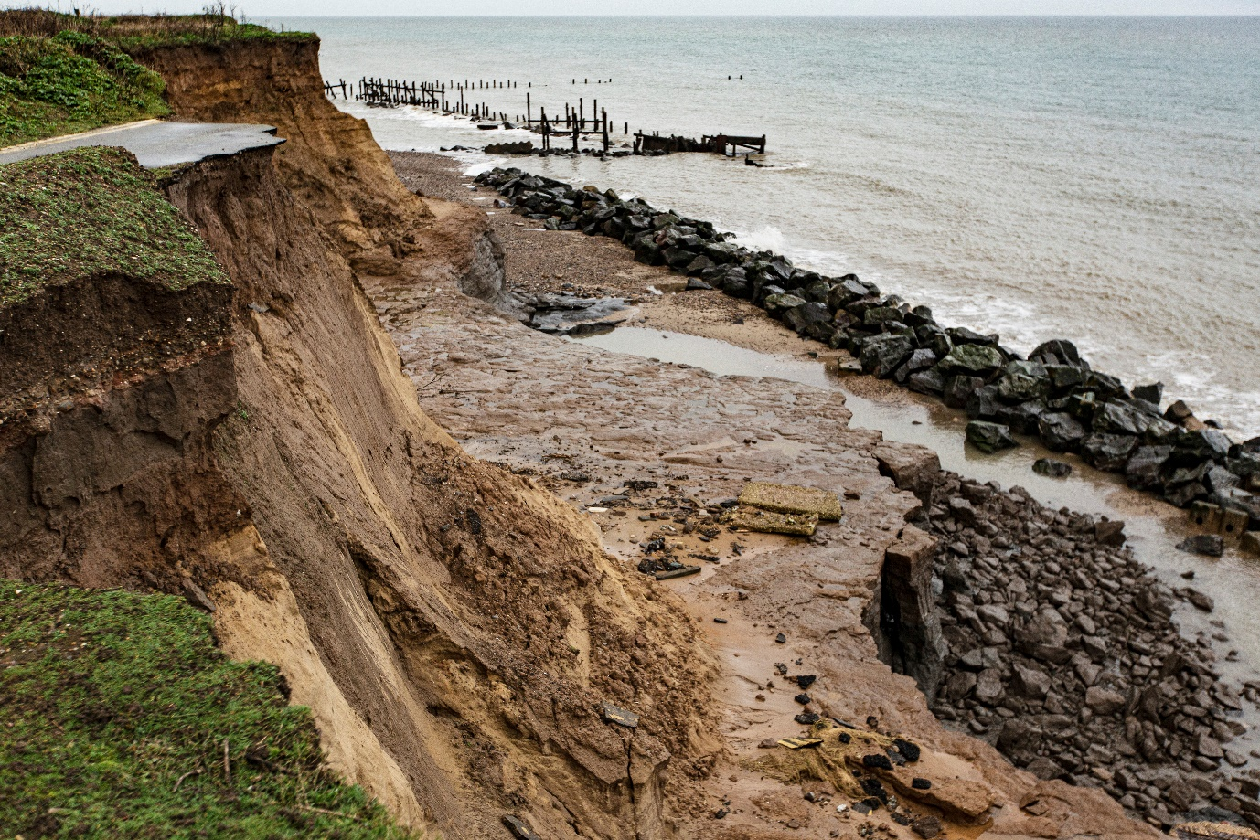
Fig10

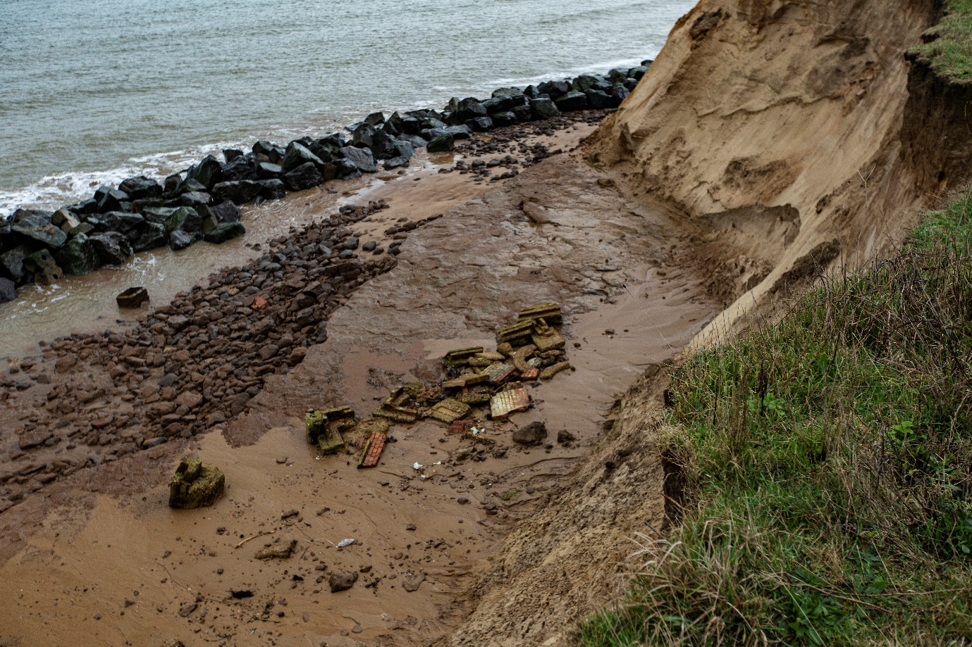
Fig 11 Rear of Beach Road bungalow (Fig 4). Outbuilding collapsed in last two months

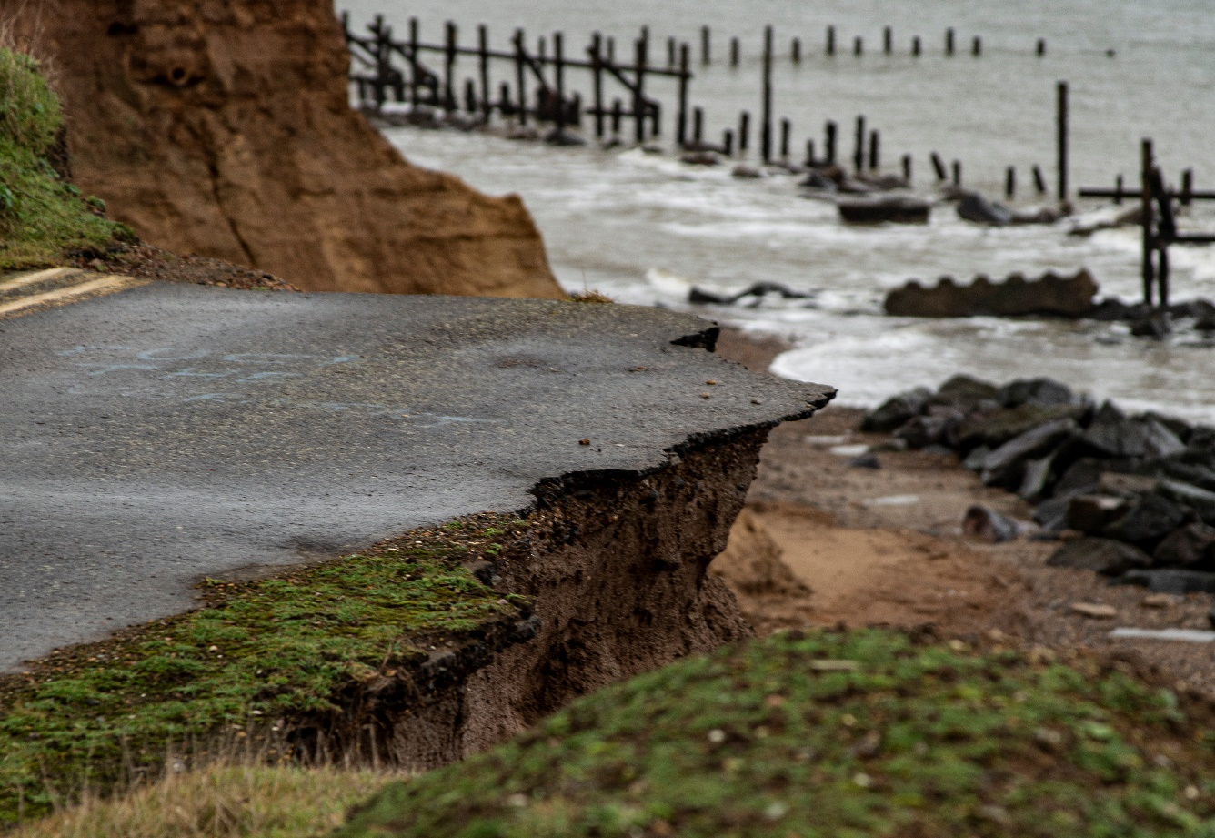
Fig 12

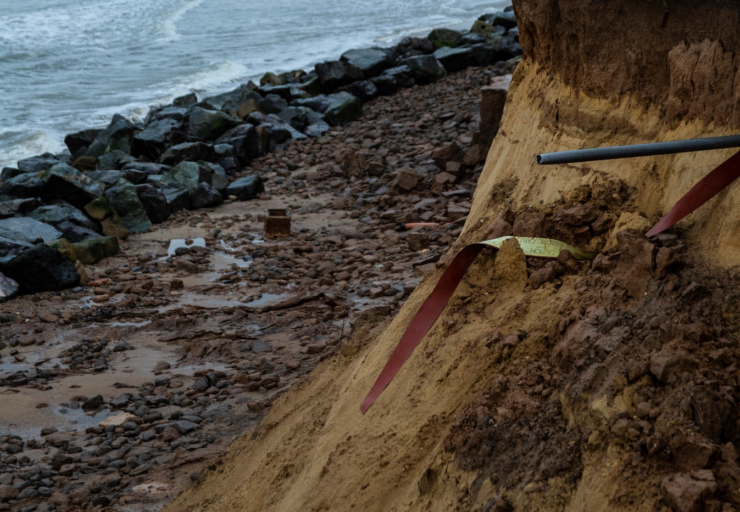
Fig 13

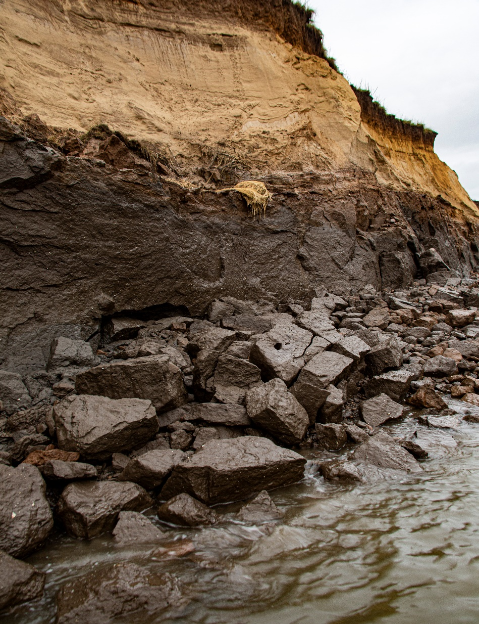
Fig 14

